
Artificial Intelligence (Lab)
Mr. Rasikh Ali
Name: Afaq Akhtar
Roll No: SU92-BSSEM-S25-060

The Superior University
AI Lab Tasks
Lab 05

Adversarial Search: Minimax & Alpha-Beta Pruning

Task 1: Trace of the Supplied Tree (Minimax)
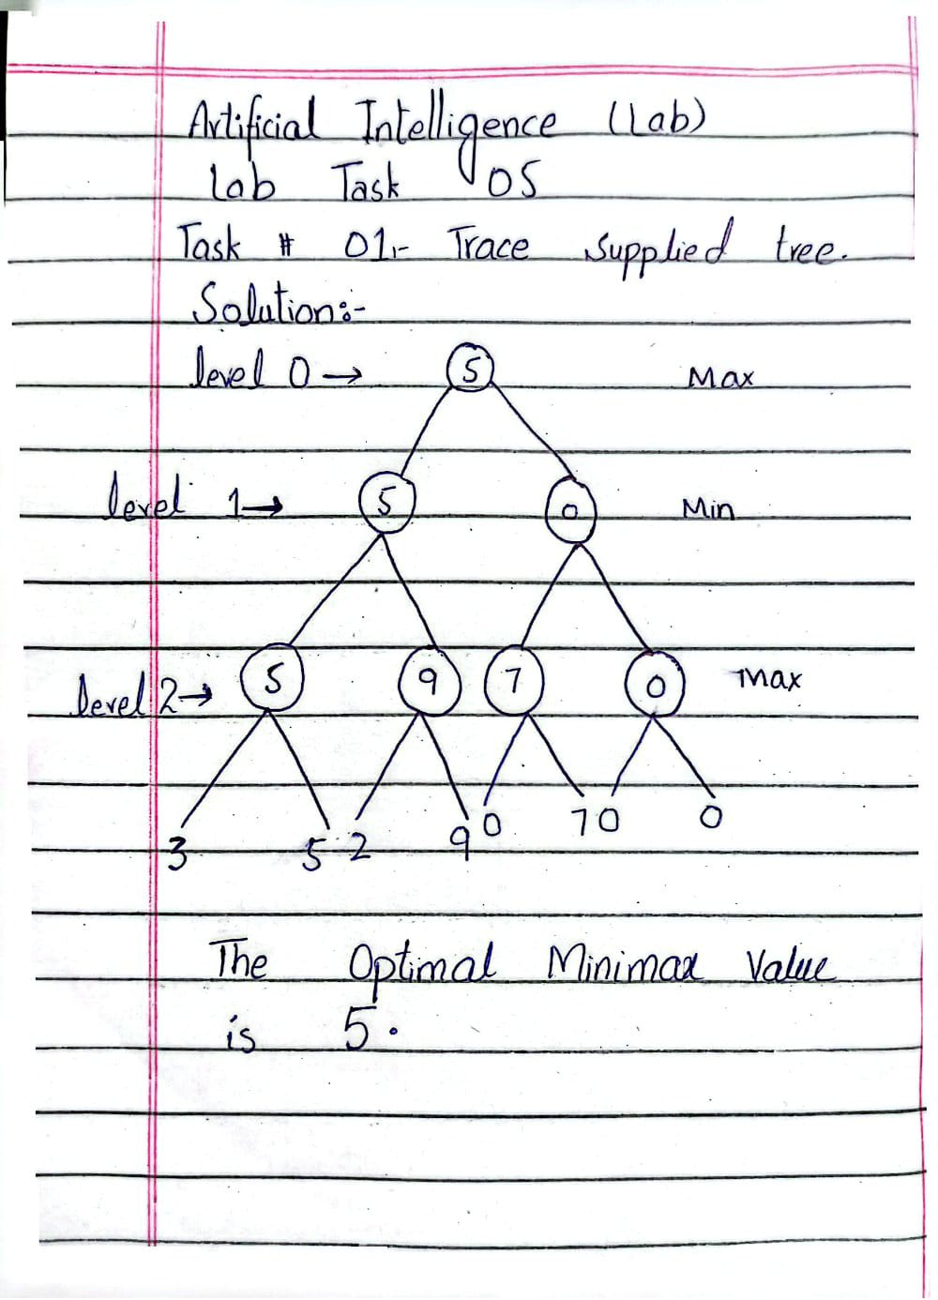
Step 1 - Level 2 (MAX nodes), each MAX node takes the larger child:
max(3, 5) = 5, max(2, 9) = 9, max(0, 7) = 7, max(0, 0) = 0
Step 2 - Level 1 (MIN nodes), each MIN node takes the smaller child:
min(5, 9) = 5, min(7, 0) = 0
Step 3 - Level 0 (Root, MAX node), the root takes the larger child:
max(5, 0) = 5
Result: The optimal Minimax value is 5. The best first move for MAX is the left branch, because it guarantees 5, while the right branch guarantees only 0 against an optimal opponent.
Task 2: Add a Leaf-Evaluation Counter to Both Algorithms
2. Code Implementation
Below is the complete implementation containing both algorithms with an integrated global leaves counter to record terminal node visits.
import math
scores = [1, 2, 3, 4, 5, 6, 7, 8]
treeDepth = math.log2(len(scores))
leaves = 0
def minmax(currDepth, nodeIndex, isMaxTurn):
global leaves
if currDepth == treeDepth:
leaves += 1
return scores[nodeIndex]
if isMaxTurn:
return max(
minmax(currDepth + 1, nodeIndex * 2, False),
minmax(currDepth + 1, nodeIndex * 2 + 1, False)
)
else:
return min(
minmax(currDepth + 1, nodeIndex * 2, True),
minmax(currDepth + 1, nodeIndex * 2 + 1, True)
)
def alphabeta(currDepth, nodeIndex, isMaxTurn, alpha, beta):
global leaves
if currDepth == treeDepth:
leaves += 1
return scores[nodeIndex]
if isMaxTurn:
best = float('-inf')
best = max(best, alphabeta(currDepth + 1, nodeIndex * 2, False, alpha, beta))
alpha = max(alpha, best)
if alpha >= beta:
return best # prune!
best = max(best, alphabeta(currDepth + 1, nodeIndex * 2 + 1, False, alpha, beta))
return best
else:
best = float('inf')
best = min(best, alphabeta(currDepth + 1, nodeIndex * 2, True, alpha, beta))
beta = min(beta, best)
if alpha >= beta:
return best # prune!
best = min(best, alphabeta(currDepth + 1, nodeIndex * 2 + 1, True, alpha, beta))
return best
print("Scores:", scores)
leaves = 0
print("Minimax value:", minmax(0, 0, True))
print("Leaves evaluated:", leaves)
leaves = 0
print("AlphaBeta value:", alphabeta(0, 0, True, float('-inf'), float('inf')))
print("Leaves evaluated:", leaves)
Output:
Scores: [1, 2, 3, 4, 5, 6, 7, 8]
Minimax value: 6
Leaves evaluated: 8
AlphaBeta value: 6
Leaves evaluated: 6
3. Results & Output Summary
Minimax Optimal Value: 6 | Leaves Evaluated: 8
Alpha-Beta Optimal Value: 6 | Leaves Evaluated: 6
Task 3: Reorder Branches and Observe How Pruning Changes
2. Code Implementation
Below is the complete implementation incorporating multiple score orderings ("Original", "Good order", and "Bad order") to test cutoff efficiency and leaf-evaluation counts using the same code structure:
import math
scores = [1, 2, 3, 4, 5, 6, 7, 8]
treeDepth = math.log2(len(scores))
leaves = 0
def minmax(currDepth, nodeIndex, isMaxTurn):
global leaves
if currDepth == treeDepth:
leaves += 1
return scores[nodeIndex]
if isMaxTurn:
return max(
minmax(currDepth + 1, nodeIndex * 2, False),
minmax(currDepth + 1, nodeIndex * 2 + 1, False)
)
else:
return min(
minmax(currDepth + 1, nodeIndex * 2, True),
minmax(currDepth + 1, nodeIndex * 2 + 1, True)
)
def alphabeta(currDepth, nodeIndex, isMaxTurn, alpha, beta):
global leaves
if currDepth == treeDepth:
leaves += 1
return scores[nodeIndex]
if isMaxTurn:
best = float('-inf')
best = max(best, alphabeta(currDepth + 1, nodeIndex * 2, False, alpha, beta))
alpha = max(alpha, best)
if alpha >= beta:
return best # prune!
best = max(best, alphabeta(currDepth + 1, nodeIndex * 2 + 1, False, alpha, beta))
return best
else:
best = float('inf')
best = min(best, alphabeta(currDepth + 1, nodeIndex * 2, True, alpha, beta))
beta = min(beta, best)
if alpha >= beta:
return best # prune!
best = min(best, alphabeta(currDepth + 1, nodeIndex * 2 + 1, True, alpha, beta))
return best
orders = [
("Original", [1, 2, 3, 4, 5, 6, 7, 8]),
("Good order", [5, 6, 7, 8, 1, 2, 3, 4]),
("Bad order", [3, 4, 1, 2, 7, 8, 5, 6])
]
for name, s in orders:
scores = s
treeDepth = math.log2(len(scores))
leaves = 0
print(name, "-> Minimax:", minmax(0, 0, True), "| Leaves:", leaves)
leaves = 0
print(name, "-> AlphaBeta:", alphabeta(0, 0, True, float('-inf'), float('inf')), "| Leaves:", leaves)
Output:
Original -> Minimax: 6 | Leaves: 8
Original -> AlphaBeta: 6 | Leaves: 6
Good order -> Minimax: 6 | Leaves: 8
Good order -> AlphaBeta: 6 | Leaves: 5
Bad order -> Minimax: 6 | Leaves: 8
Bad order -> AlphaBeta: 6 | Leaves: 8
3. Results & Comparison Summary
Test Case / Order | Minimax Value | Minimax Leaves | Alpha-Beta Value | Alpha-Beta Leaves | Pruning Performance
Original [1, 2, 3, 4, 5, 6, 7, 8] | 6 | 8 | 6 | 6 | Moderate cutoffs
Good order [5, 6, 7, 8, 1, 2, 3, 4] | 6 | 8 | 6 | 5 | Maximum pruning achieved
Bad order [3, 4, 1, 2, 7, 8, 5, 6] | 6 | 8 | 6 | 8 | No pruning - all leaves evaluated

